PROPELLER CONTROL AND OPERATION
This system results in constant speed by producing what is known as an ON SPEED condition, which exists when the RPM is constant. Movement of the cockpit controls have set the speeder springs at the desired RPM. The flyweights have positioned the pilot valves to direct oil to or from the propellers. This, in turn, has positioned the propeller blades at a pitch that absorbs the engine power or RPM selected. When the moment of RPM balance occurs, the force of the flyweights equals the speeder spring load. This positions the pilot valves in the constant RPM position with no oil flowing to or from the propellers. (Figs. 9A & 9B)
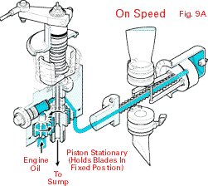 | 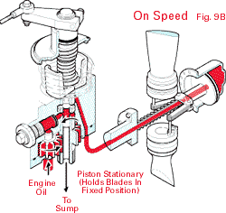
At constant-speed, an OVERSPEED condition results and airspeed increases when the airplane begins a descent or engine power is increased. Since the pitch of the propeller blades is too low to absorb engine power, the engine RPM begins to increase. At the instant this happens, however, the flyweights move out and raise the pilot valves, causing oil to flow from the propellers in a full-feathering system (Fig. 10A) and to the propeller in a constant-speed system (Fig. 10B), increasing the pitch of the blades in both cases. Engine speed then slows to the original RPM setting.
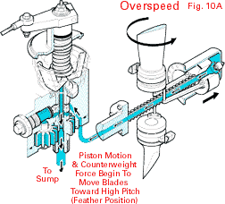 | 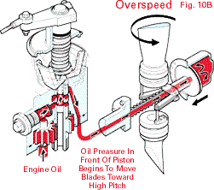

If the airplane begins to climb or engine power is decreased, an UNDERSPEED condition results. Airspeed is reduced and, since the pitch of the propeller blades is too high, the engines begin to slow down. At the instant this happens, the flyweights will droop, causing the pilot valves to move down. Simultaneously, oil flows to the propellers in a full-feathering system (Fig. 11A) and from the propeller in a constant-speed system (Fig. 11B), reducing the pitch of the blades in both cases. This automatically increases the speed of the engines to maintain the original RPM setting.
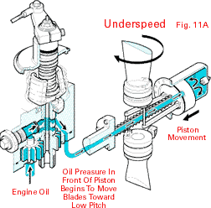 | 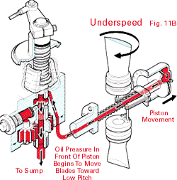
Feathering
Feathering is achieved through a mechanical linkage that overrides the flyweights and speeder spring. When the cockpit control is moved to ³feather,² the governor lever and shaft are turned beyond normal low-RPM operating limits. As the threaded shaft backs out, the shaft lift rod engages the pilot valve spindle and lifts the pilot valve. This causes oil to flow out of the propeller, and it moves to feather pitch position. (Fig. 12)
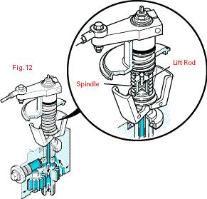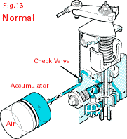
Unless the airplane is equipped with the unfeathering accumulator option, the pilot can ³unfeather² the propeller by moving the propeller control to high RPM (low pitch) and engaging the engine starter. When the engine is turning over fast enough to develop sufficient oil pressure, the propeller blades will be forced out of feather.
The unfeathering accumulator option permits a feathered propeller to be unfeathered in flight for air-starting the engine. With this option, the governor is modified to provide an external high-pressure oil outlet through a check valve, as well as a device for unseating the check valve. The external outlet is connected to an accumulator. One side of the accumulator is filled with compressed nitrogen and the other side with oil.
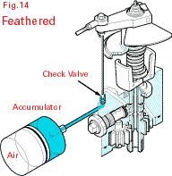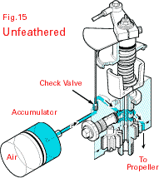
This allows the oil to be stored under high pressure, as it is during normal flight. (Fig. 13) When the propeller is feathered, the check valve maintains oil pressure in the accumulator. (Fig. 14) When the propeller control is moved from feather to low pitch, the check valve is unseated, permitting the high-pressure oil in the accumulator to flow to the governor pilot valve. With the governor control lever and shaft in low pitch, the speeder spring forces the pilot valve down so that the oil flows to the propeller and moves the blades to low pitch. (Fig. 15)
PERFORMANCE CONSIDERATIONS
Shape of Propeller Tips
Propeller tips can be rounded, swept or square. Various tips are often used to meet blade vibration resonance or special design conditions. Tip shape is also a function of aesthetics, noise requirements, flight performance, repairability and ground clearance.
Propeller Diameter
Propeller diameters are a function of engine and airframe limitations. Larger propeller diameters are preferred for low airspeed operation, while smaller diameters are best for high airspeeds. For example, the diameter of a fixed-pitch propeller is often large to favour low airspeed operation, while the blade size is small to favour higher airspeeds and faster turning at low airspeeds. The diameter and blade size of a constant-speed propeller is often larger (than a fixed-pitch), due to the variability of blade angles.
Engine Horsepower and RPM
For fixed-pitch props, at a fixed throttle setting, propeller and engine RPM increases or decreases with the airspeed. At a constant airspeed, fixed-pitch propeller and engine RPM change if power is increased or decreased. A constant-speed prop uses a governor to provide constant RPM at the selected throttle setting. The blade angle automatically increases or decreases as the RPM setting or engine power changes. With a fixed RPM and power setting, the blade angle automatically changes as airspeed increases or decreases.

